Matthew Hoffman

CpE 403 – Advanced Embedded Systems

Lab 9

# Task 1:

Task 1 asked to comment the given code, run it, graph it, and grab the cycle count to calculate the trigonometric equation given by setting breakpoints at line 33 and line 42. The breakpoint property count allows the number of cycles to be counted between the two. Using the given clock of 50MHz we can calculate how long it takes to complete.

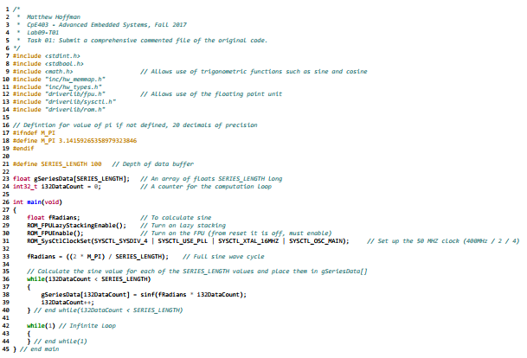

Figure 1. Lab09-T01 Source Code

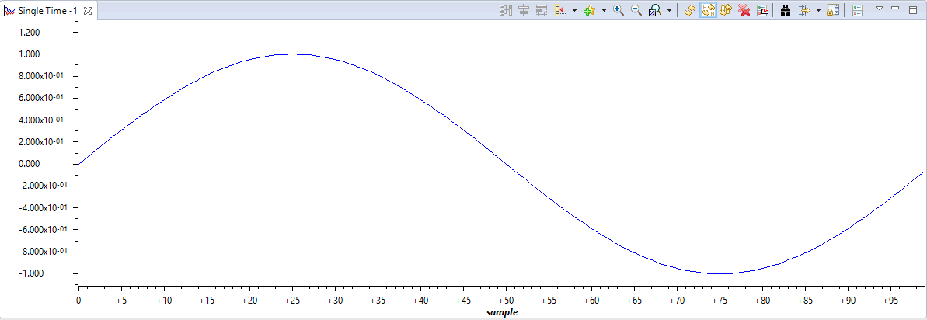

Figure 2. Lab09-T02 Sine Graph

# Task 2:

For Task 2 the defined value SERIES_LENGTH simply needed to be changed to 1000 (line 24) and the accompanying trigonometric equation to store values in gSeriesData (line 41).

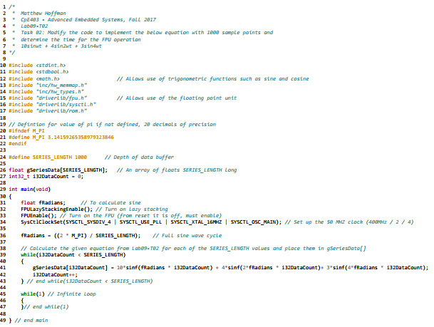

Figure 3. Lab09-T02 Source Code

To determine the FPU time to completion we needed to track how many CPU cycles it took. By setting a breakpoint prior to the FPU operations to be taken and a breakpoint upon completion we can see how many CPU cycles it takes (in this case, 313435 – 3423 = 310012 Cycles). We have a clock of 50MHz which means 20us per cycle. 310012 * 20us = 0.00620024 = 6.2ms

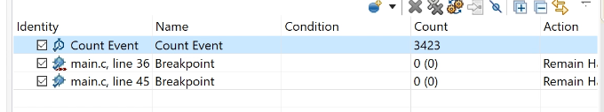

Figure 4. Lab09-T02 First Breakpoint (at line 36 of source)

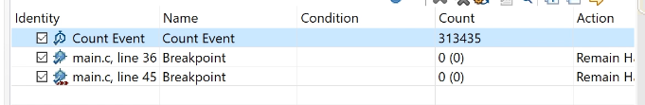

Figure 5. Lab09-T02 Second Breakpoint (at line 45 of source)